GitHub:
Fragments:
https://github.com/MansoorAZafar/fragments/tree/main
Integration Tests:
https://github.com/MansoorAZafar/fragments/tree/main/tests/integration
Hurl successfully running all integration tests
(Running hurl while docker compose is running)
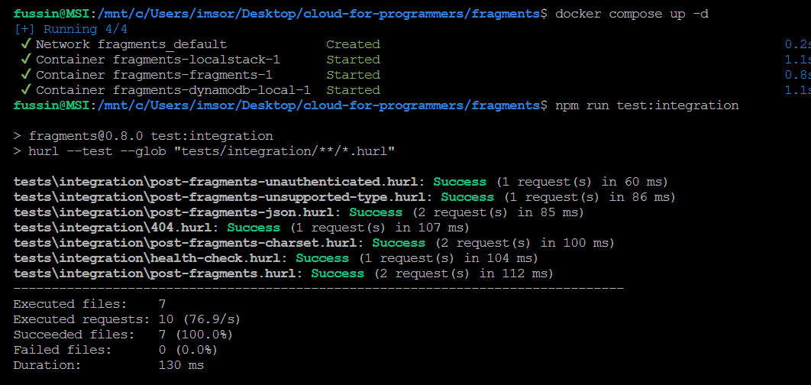
(Running locally)
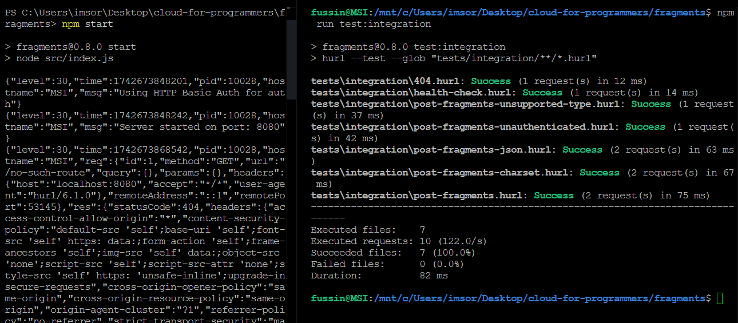

All three containers successfully being started with Docker compose
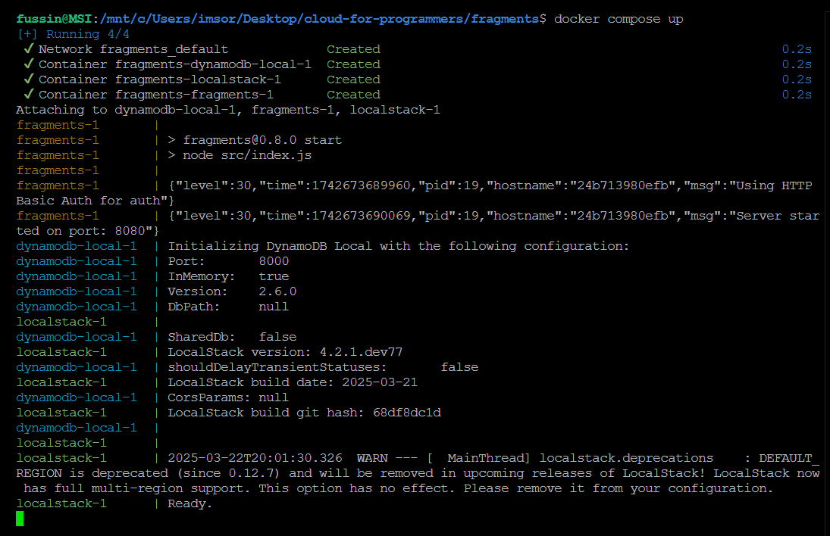
Local-aws-script.sh running successfully
